# VLOOKUP core concepts

Functions can be used to quickly find information and perform calculations using specific values. In this reading, you will learn about the importance of one such function, **VLOOKUP**, or Vertical Lookup, which searches for a certain value in a spreadsheet column and returns a corresponding piece of information from the row in which the searched value is found.

A VLOOKUP function is available in both Microsoft Excel and Google Sheets. Let's start by looking at an example of the way VLOOKUP is used and the general syntax associated with it in Google Sheets. (You can refer to the resources at the end of this reading for more information about VLOOKUP in Microsoft Excel.)



## Sample usage



Let's break down the syntax.



### **search_key**

* The value to search for.
* For example, 42, "Cats", or I24.

### **range**

* The range to consider for the search.
* The first column in the range is searched for the key specified in search_key.

### **index**

* The column index of the value to be returned, where the first column in range is numbered 1.
* If index is not between 1 and the number of columns in range, #VALUE! is returned.

### **is_sorted**

* Indicates whether the column to be searched (the first column of the specified range) is sorted. TRUE by default.
* It’s recommended to set is_sorted to FALSE. If set to FALSE, an exact match is returned. If there are multiple matching values, the content of the cell corresponding to the first value found is returned, and #N/A is returned if no such value is found.
* If is_sorted is TRUE or omitted, the nearest match (less than or equal to the search key) is returned. If all values in the search column are greater than the search key, #N/A is returned.

## When do you need to use VLOOKUP?

Have you ever had data that exists in two spreadsheets, but you need both spreadsheets to solve the problem? VLOOKUP can connect your two sheets together, on a matching column, to populate one single sheet. Check out the spreadsheet.

You may click the link to create a copy of the spreadsheet: [VLOOKUP Example](https://docs.google.com/spreadsheets/d/10tEwQxOU3EbAXJfRwDUWuWFx2oytjY8YUc54U5Y7TfY/copy).

Or, if you don’t have a Google account, download the template directly from the attachment below.

[VLOOKUP Example.xlsx](https://d3c33hcgiwev3.cloudfront.net/Wq_usw3TTyuv7rMN068rkA_1a49174562ec4482a47c94890b33f668_VLOOKUP-Example.xlsx?Expires=1617494400&Signature=CRlmKLDXHsGbPipd1waJfjJcKBpC84sGRQDDu3oTENJgzg~xwStO-ow4MWrAduToSnBC8cLmzms~SKPk4Enpm6rSmu1jzNF73IIdSbc2B9U66o6ww5ElU3UYUpS62Jj10jyPIVUND4~HJVsxVQQ1ckJM9KEnIadgVGrETJua4ow_&Key-Pair-Id=APKAJLTNE6QMUY6HBC5A)

This is a great example of why you'd want to use VLOOKUP. You can easily use VLOOKUP to pull employee hours from one tab, and employee rates from another, and use it to calculate final pay.

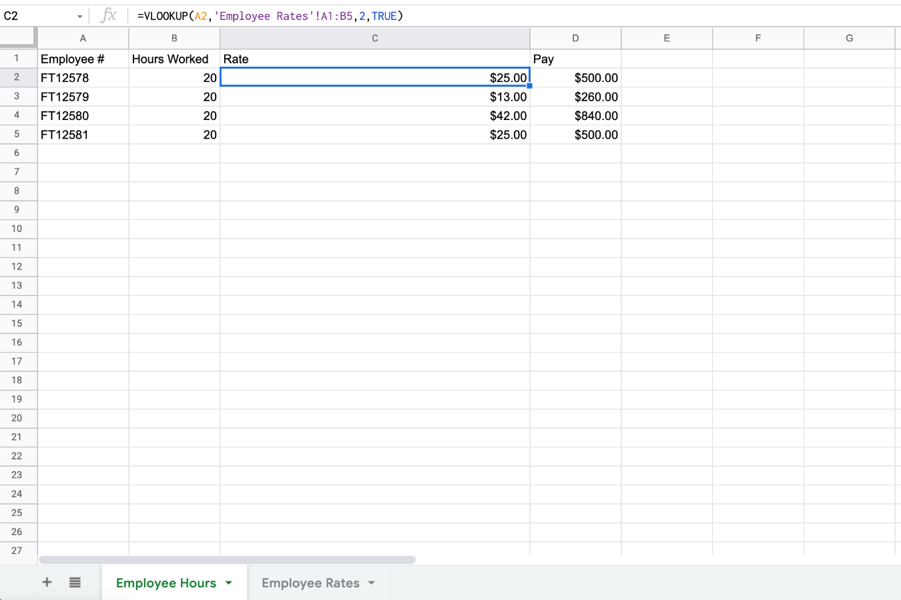

## Helpful VLOOKUP reminders

* TRUE means approximate match, FALSE means exact match.
* You want your VLOOKUP column to be on the left hand side of your data. The VLOOKUP only looks at data to the right. This may require you to move columns around before you use the VLOOKUP.
* Once you’ve populated data with the VLOOKUP formula, copy and paste as values before you start to manipulate the data.

## VLOOKUP resources for Microsoft Excel

* [H​ow to use VLOOKUP in Excel](https://support.microsoft.com/en-us/office/vlookup-function-0bbc8083-26fe-4963-8ab8-93a18ad188a1): This tutorial includes a video to help you get a general understanding of how the VLOOKUP function works in Excel, as well as practical examples to look through.
* [VLOOKUP in Excel tutorial](https://www.youtube.com/watch?v=d3BYVQ6xIE4): Follow along in this video lesson and learn how to write a VLOOKUP formula in Excel and master time-saving useful tips and tricks.
* [23 things you should know about VLOOKUP in Excel](https://exceljet.net/things-you-should-know-about-vlookup): Explore this list of 23 VLOOKUP facts as well as challenges you might run into, and start to learn how to master them.
* [How to use Excel's VLOOKUP function](https://edu.gcfglobal.org/en/excel-tips/how-to-use-excels-vlookup-function/1/): This article shares a specific example around how to apply VLOOKUP in your searches.
* [VLOOKUP in Excel vs Google Sheets](https://infoinspired.com/sheets-vs-excel-formula/vlookup-formula-in-excel-and-google-sheets/): This guide offers a VLOOKUP comparison of Excel and Google Sheets.